HW 5 – CIS 4374
Research:
What does already exist?
I found parking platforms that are popular in the market like ParkMobile, SpotHero, Parksy, and PayByPhone.
Add existing software landscape to your document
After doing my research on these five popular parking platforms, they have their own parking app for both App Store and Google Play. They also have a ton of features that set each other apart such as real-time availability, pre-booking, long-term parking, and easy payment options. One con about all the parking platforms is that they are limited to only big cities.
How will your application be different from what already exists?
My application will be different from what already exists by adding in all the features that exist including AI assisted chat, big cities, and little cities parking, website for the instructions meaning step by step guide on how to use the application, support, easy accessibility and usage, gps navigation with Apple Maps or Google Maps on the platform, simple payment methods, book a parking reservation ahead of time for future events and scout for the cheapest parking in the location near the area.
Vision and Scope
How was this project acquired, introduction of my fictional company and a rough overview of what this project is about?
The project was introduced and acquired when I was trying to find parking for my date, and I was struggling to find parking that was nearby and close to the date spot. I tried all these parking apps, and they found me at parking spots that were 20 minutes walking distance away from the date spot. I was frustrated with having to walk a mile to get to my spot, so I developed a smart parking spot application that allows everyone to find good parking and have the functionality and usage like all the other apps. The overview of this project is to help drivers find parking easier by implementing an application that allows drivers to find out and show parking spaces. This also helps parking operators to decide what rates to charge, check parking efficiently, and improve the parking situation for drivers. That is why I introduced a company to the name of $oftware Corp to help drivers get out frustrating situations over parking.

Draft for SRS
- Software Requirements Specification (SRS)
- Project Name: Smart Parking Platform
- Version: 3.2
- Date: 09.10.2026

- Introduction
- 1.1 Purpose
  - This document defines the requirements for Smart Parking Platform project.
- 1.2 Scope
  - We will include

2. Overall Description
- - Users: People above 18 that can drive, the age demographic where people can drive
- - System environment: Web-based / Mobile application
- - Constraints: Must have a device to use, must require payment method
- - Assumptions: Application has internet access; real-time availability

3. Functional Requirements
- FR1: The system should allow the user to register and log in securely.
- FR2: The system should allow the user to add and choose payment methods.
- FR3: The system should display a search bar to search for addresses.
- FR4: The system should generate and email payment receipts.
4. Non-Functional Requirements
- NFR1: The system should support at least 2,000 active users.
- NFR2: The system should display live parking within 10 minutes.

Use Case
1.
- Title: Add user registration to the web-based / mobile application
- Actor: User
- Precondition: User fills in information, user logs in
- Steps:
- 1. User selects “Sign Up” or “Register
- 2. User fills in personal information
- 3. User verifies email address
- 4. User is officially setting up an account.
- Postcondition: users can login
2.
- Title: Add user payment method
- Actor: User
- Precondition: User adds payment method for future uses
- 1. User selects the payment method (Debit/Credit)
- 2. User enters their payment information
- 3. User now has a form of payment.
- Post condition: payment can now be available for use
3.
- Title: Multifactor Authentication
- Actor: User
- Precondition: User adds multifactor authentication to secure login
- 1. User selects “Login information”
- 2. User selects “MFA authentication”
- 3. User setups MFA via email
- 4. User tests the MFA by logging out and logging in
- Post condition: mfa setup is complete
4.
- Title: Add search bar for parking search
- Actor: User
- Precondition: users use search bar to find parking spots
- Steps:
- 1. User clicks or taps on the search bar
- 2. User searches nearest parking spots
- 3. User finds a parking nearby parking spot
- Postcondition: search bar is available for use
5.
- Title: Add live update for parking space availability
- Actor: User
- Precondition: user refreshes parking space to see if it becomes available
- Steps:
- 1. User searches for parking spaces
- 2. User finds a parking space
- 3. User views that parking spaces are full
- 4. User taps the refresh button
- 5. User finds a parking space
- Post Condition: refresh button gives update to display
6.
- Title: Add interactive map to display parking spots/locations
- Actor: User
- Precondition:
- 1. User arrives at the destination
- 2. User cannot find parking spot
- 3. User searches for parking spots nearby
- 4. User sees parking spots by looking at an interactive map
- Post condition: interactive map can move and display parking spots nearby
7.
- Title: Add apple pay or google pay as a form of payment
- Actor: User
- Precondition: user finds parking spot and pays for parking spot using apple/google pay
- 1. User finds a parking spot
- 2. User pays for the parking spot
- 3. The system gives the user multiple option methods credit or apple pay or google pay
- 4. User uses google pay or apple pay to pay
- Post condition: apple pay and google pay are available for use
8.
- Title: Add parking reservation
- Actor: User
- Precondition: user purchases parking reservation
- 1. User wants to book a parking reservation for an event
- 2. Users find parking space available for an event the next day
- 3. User books a parking reservation for the event
- Post condition: parking reservation is available for purchase
9.
- Title: Add a calendar for parking reservation
- Actor: User
- Precondition: users book a parking reservation, calendar is installed
- 1. User wants to book reservation for the day/week/month ahead of time
- 2. User finds a solid parking space
- 3. User books the parking reservation
- 4. User finds the parking spot on the calendar
- Postcondition: calendar is available and shows parking reservation
10.
- Title: Add an email confirmation for booking parking reservation
- Precondition: users book a parking reservation, email confirmation is installed
- Actor: User
- 1. User book a parking reservation
- 2. User pays for a parking reservation
- 3. User gets email confirmation of the parking reservation
- Post condition: email confirmation is ready for use
11.
- Title: Add reservation history and receipts
- Actor: User
- Precondition: user purchases a parking reservation, reservation history and receipts installed
- 1. User finds a parking space or reservation
- 2. User purchases parking space or reservation
- 3. User checks the reservation history and receipt
- Postcondition: user’s reservation history and receipt are available to view
12.
- Title: Add a dashboard for parking operators
- Actor: Parking Operator
- Precondition: parking operator can view the dashboard
- 1. Operator can view live parking reservations and feedback
- 2. Operator can edit the dashboard
- 3. Operator can change the parking situation to active/inactive
- Postcondition: dashboard is ready to use and configure according to operator
13.
- Title: Add features on the dashboard to make accessibility easier
- Actor: Parking Operator
- Precondition: operator adds features to make dashboard accessible
- 1. Operator configures the dashboard
- 2. Operators view the dashboard
- Postcondition: dashboard is easier to view and mess with
14.
- Title: Add app and email notification for users
- Actor: User
- Precondition: user books a reservation, app and email notification installed
- 1. User books a parking reservation
- 2. User sees the parking reservation history
- 3. User gets an email and app notification of the booking
- Postcondition: email and app notification will be sent to the user of booking
15.
- Title: Add alerts for users
- Actor: User
- Precondition: user receives alert for app that parking is full
- 1. User uses search bar to type in a spot
- 2. User tries to find parking around the area
- 3. User receives an alert for the spots being filled
- Post condition: alert notifies the user, alert is available

Deliverables:
1.0: Research for the Smart Parking Platform Project
1.1: Explain the research through various questions
1.2: Create Software Requirements Specifications (SRS) Draft
1.3: Create 15 cases that the user/operator will use in the application interface
1.4: Create deliverables for the project steps
1.5: Create WBS for the parking app
1.6: Create a Gantt Chart to visualize the timeline of the project
1.7: Changing the version of the SRS for every change of the project
1.8: Create a backlog for Parking App
1.9: Plan Sprint 1 Backlog
2.0: Make a table for at least 4 risks for each category: Technical, Schedule, Financial, and People
2.1: Create a Communication Plan
WBS for Parking App
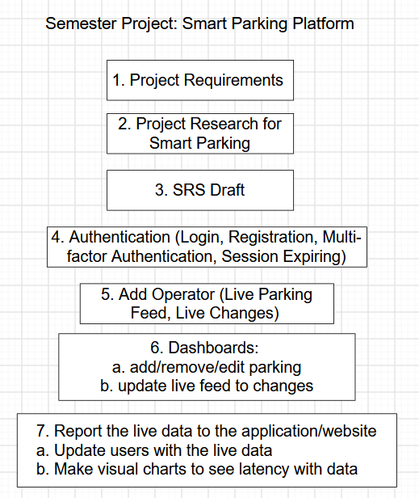
Gantt Chart
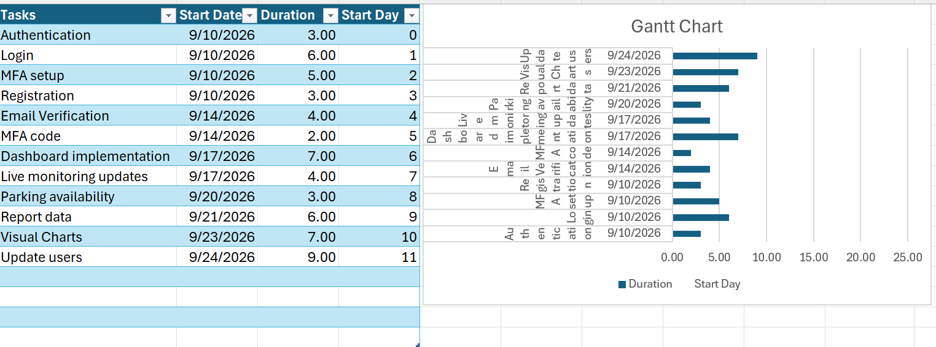

Trello Board for Backlog and Sprint Plan 1 Screenshots
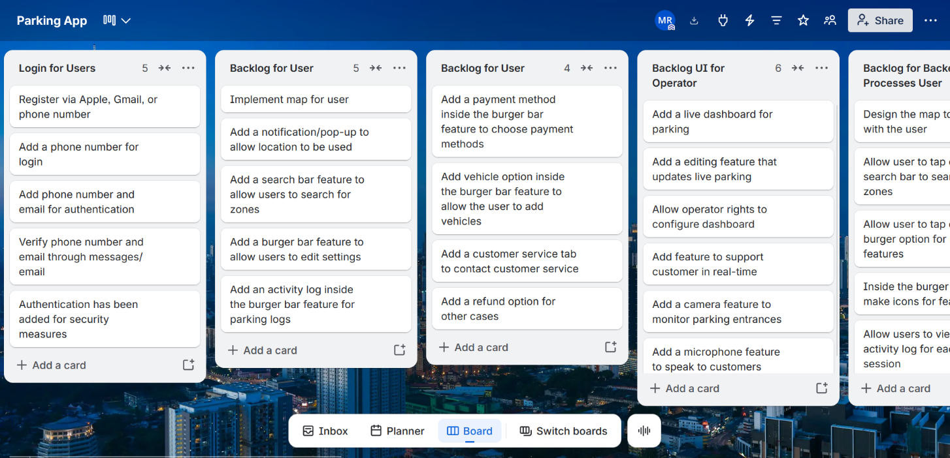
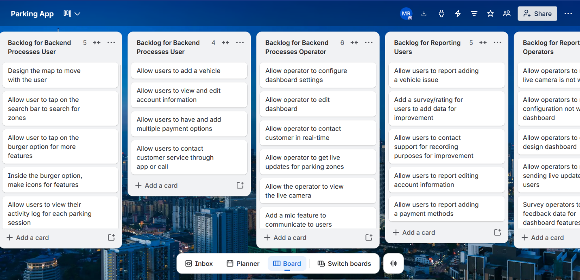

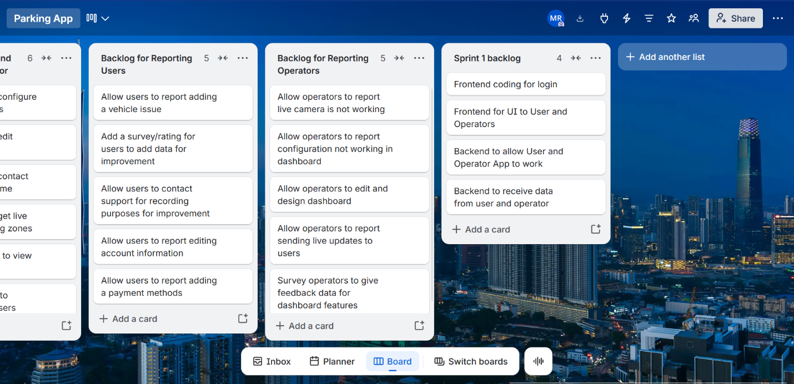
Table for identifying and listing at least 4 risks each category: Technical, Schedule, People, Financial
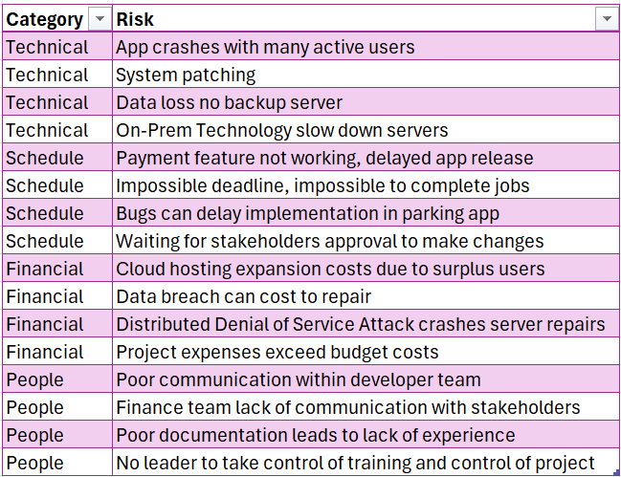
Risk Register
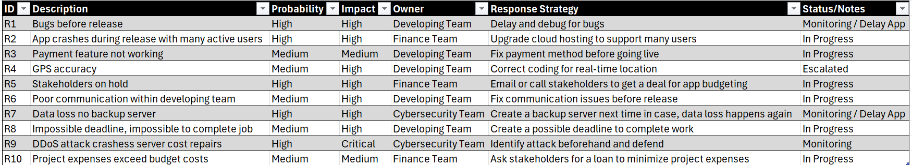
Communication Plan
Team | Meeting | Cadence | Reporting Method
Development Team | Daily Scrum | Daily | Scrum Leader
Cybersecurity Team | Bug and vulnerability meeting | Bi-weekly | Senior Cybersecurity Analyst or Engineer
Finance Team | Budget + Weekly Costs Meeting | Weekly | President of the Finance
Technician Team | Repair & Maintenance Meeting | Weekly | Repair + Maintenance Senior
UX Design Team |  | Weekly | UX Design Manager
Stakeholders/Investors |  | Monthly | Project manager
Project Manager | Leader of meetings | Weekly | Project manager
City | City partnership meeting | Semi-Monthly | Partnership
All teams | Sprint Review + Project Overview: Month 1 | Monthly | Recorded meeting through Teams or Zoom

Roles and Resources
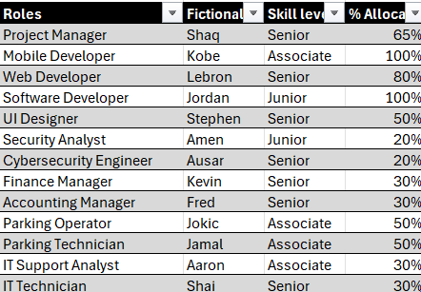
Cost Plan
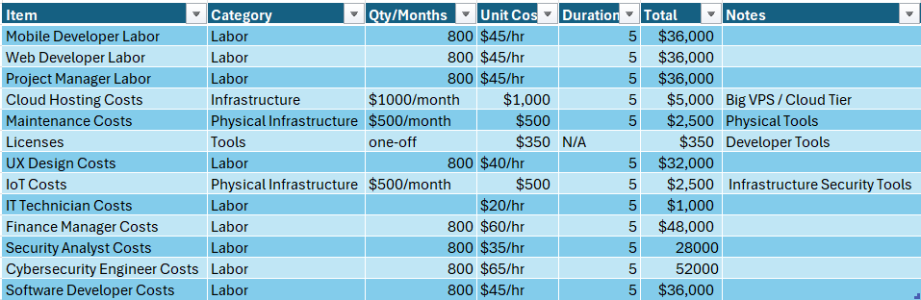
Resource Plan
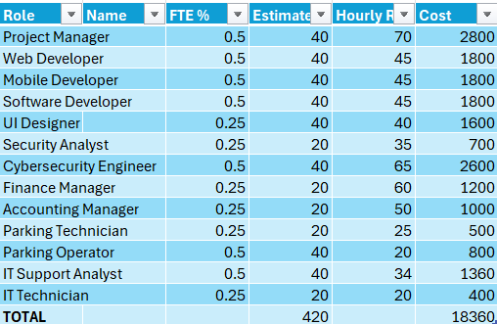
RACI matrix
